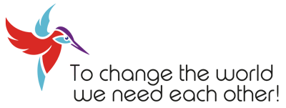

***Invitation***

**To all who are committed to a fair, peaceful and sustainable world**

Around the world there are initiatives that are active for the welfare of humans and animals, clean water, nature conservation and for peace and balance. ***One Planet - One People*** connects people and organizations that strive for this better world.

***Gathering 2020: A Better World? Let’s do it together!***

From 22 - 29 August 2020, ***One Planet - One People*** is organizing an international meeting at Centre Lothlorien in Foulain, France. During this Gathering we want to give everyone the opportunity to share knowledge, experience and intentions. Together we are stronger to build a better world. Be inspired, let your voice be heard, come and tell us what you think and what your organization or project stands for. We would like to invite you to attend this international meeting on behalf of your project, organization or initiative.

***Unity in Diversity***

When we are able to bridge differences and embrace agreements, then that beautiful world is not a Utopia, but close to realization.

***To Change the World we need Each Other***

If we all do our bit every day, that means the difference worldwide.

On our website [**www.oneplanet-onepeople.org**](http://www.oneplanet-onepeople.org) you can read what we are committed to.

We look forward to welcoming you!

On behalf of the ***One Planet - One People*** project team,

Lucas Slager

[***centrelothlorien@gmail.com***](mailto:centrelothlorien@gmail.com)

Domaine de Moiron • 52800 Foulain • France •

0033 (0)325 034086

www.oneplanet-onepeople.org

**DONATIONS** Triodos Bank NL40TRIO 078.47.65.111,

BIC TRIONL2U t.n.v. V.V. Lothlorien.

